Faculty of Engineering and Technology
Department of Computer Engineering

CrowdSensed
Dynamic Mobile Network Monitoring System

Task 6: Database Design and Implementation Report

Group 7 | FET-UB | Academic Year 2025/2026

1. Introduction
This report documents the complete database design and implementation for the CrowdSensed Mobile Network Monitoring System as required by Task 6. It covers seven key deliverables: the mobile application’s transition from a simulated frontend prototype to a live, hardware-driven telemetry collector, the data elements managed by the system, the conceptual design, the Entity-Relationship (ER) diagram, the database implementation, the backend implementation, and the connection of the database to the backend. Each section is supported by architecture diagrams and, where applicable, screenshots of the running system.
The CrowdSensed system consists of three components working together: a PostgreSQL database extended with the PostGIS extension for spatial data storage, a Node.js and Express REST API exposing authentication, sample, report, analytics and coverage endpoints under /api/v1, and a React web dashboard which consumes this API through an Axios client with JWT-based authentication. A React Native mobile application also contributes measurements to the same backend.
The Crowdsensed Mobile Network Monitoring Application was initially developed as a frontend prototype designed to demonstrate the concept of collecting and displaying mobile network performance information, using simulated values to represent cellular network conditions. During the system improvement phase documented in Section 2 below, the application was transformed from a static visualisation prototype into a dynamic crowdsensing platform capable of collecting real-time cellular network measurements directly from an Android device, communicating with the device modem through the Android Telephony framework, storing measurements locally when offline, and synchronising collected data with the centralised backend and PostgreSQL database described in the remainder of this report.

2. Mobile Application Implementation
This section documents the mobile-application-side engineering work that preceded and motivated the database and backend design described in the rest of this report. It covers the removal of simulated network data, the integration of the Android TelephonyManager framework, the processing and mapping of raw telemetry into usable signal indicators, a navigation architecture fix discovered during integration testing, and the offline-first data storage mechanism that guarantees no measurement is lost when a device temporarily loses connectivity.

2.1 Transition from Simulated Data to Real Network Telemetry Collection
The original version of the application relied on frontend simulation techniques to generate network metrics. The analytics interface periodically updated displayed values using JavaScript timers and random mathematical variations, using a continuous update mechanism based on setInterval() combined with random value generation. Although this approach was useful during early interface development, it introduced several limitations because the displayed values did not correspond to the actual cellular environment of the user.
For example, values such as signal strength, quality indicators, and network identifiers were generated locally within the application rather than being retrieved from the mobile device. This meant that:
- displayed values could not represent real network coverage;
- collected information could not be used for network analysis;
- simulated values could accidentally be stored as real measurements.
To solve this problem, all artificial data generation logic was removed from the frontend. The application now initialises all network-related variables using empty loading states until real measurements are received from the device hardware. This ensures that the user interface only displays verified values obtained from the Android operating system. The new implementation follows a hardware-driven approach where the mobile device becomes the source of truth for all network measurements.

2.2 Android TelephonyManager Integration
The major modification introduced into the application was the integration of the Android TelephonyManager framework. TelephonyManager provides access to information about the cellular communication subsystem of an Android device. Through this API, the application can retrieve information about the currently connected cellular network, including signal measurements and cell identifiers.
The React Native application communicates with the native Android layer through the React Native bridge mechanism. This allows JavaScript components to request information that is normally only accessible through Android native APIs. The application continuously requests updated information from the device modem using a controlled polling mechanism: a monitoring process runs every four seconds and retrieves the latest available cellular information using the TelephonyManager service.
The polling mechanism was implemented inside a React useEffect() lifecycle hook to ensure that:
- data collection starts when the screen loads;
- updates are automatically reflected in the interface;
- resources are released when the screen is removed.
This replaced the previous artificial update loop with real device measurements.

2.3 Network Telemetry Processing and Mapping
Raw cellular information obtained from Android is returned through the CellInfo structure. Because the returned data contains multiple possible cell technologies, the application performs processing before displaying information. The application extracts the required telemetry values and maps them into dedicated React state variables. The main collected parameters include:
Reference Signal Received Power (RSRP)
RSRP represents the received power level of the reference signal transmitted by the cellular base station. It is one of the main indicators used to evaluate coverage quality.
Reference Signal Received Quality (RSRQ)
RSRQ measures signal quality by considering both signal strength and interference levels.
Received Signal Strength Indicator (RSSI)
RSSI represents the total received radio energy from the serving cell and surrounding interference sources.
Signal-to-Interference-plus-Noise Ratio (SINR)
SINR evaluates the quality of the connection by comparing the desired signal against interference and background noise.
Physical Cell Identifier (PCI)
PCI identifies the connected cellular cell and allows differentiation between nearby base stations.
Network Type
The application identifies the active radio technology such as LTE or 5G.
These values are stored in component states and dynamically update the analytics dashboard and advanced network parameter interface. The result is a live monitoring interface that changes according to real movement, signal variation, and cell changes experienced by the device.

2.4 Application Navigation Architecture Improvement
During integration testing, a navigation issue was identified where the application attempted to open the analytics interface but the navigation system did not recognise the requested route. The problem occurred because the Analytics screen existed as an independent React Native component but was not registered inside the global navigation stack. The application previously attempted navigation using a route name that did not exist in the navigator configuration.
To solve this issue, the navigation architecture was updated. The Analytics screen was imported into the main navigation configuration and added as an official screen within the Stack Navigator. All route names were synchronised across components to prevent navigation mismatch errors. The HomeScreen now correctly navigates to AnalyticsScreen, while the AnalyticsScreen uses the navigation stack back operation to return to the previous screen. This created a stable navigation flow across the application.

2.5 Offline Data Storage Implementation
A crowdsensing application must continue collecting measurements even when the device temporarily loses internet connectivity. To support this requirement, an offline storage layer was introduced using React Native AsyncStorage. AsyncStorage provides a persistent key-value storage mechanism on the mobile device. It allows collected telemetry records to be stored locally until network connectivity becomes available.
The application maintains a local telemetry queue using the storage identifier:
@netpulse_offline_telemetry_queue
Whenever a network measurement is collected, the application checks the current connection status. If the device has internet access, the data is transmitted directly to the backend server. If internet access is unavailable, the measurement is converted into JSON format and stored inside the local queue. A stored measurement contains information such as:
{ timestamp, rsrp, rsrq, rssi, sinr, pci, networkType, latitude, longitude }
This approach prevents data loss and ensures that crowdsensing information is preserved even during temporary offline periods. The implementation, shown below, lives in the SyncEngine service of the React Native application and uses the AsyncStorage and NetInfo libraries to append every collected metric — including background cellular scans — to the offline-first queue, attaching an ISO timestamp before persisting the updated queue back to storage.
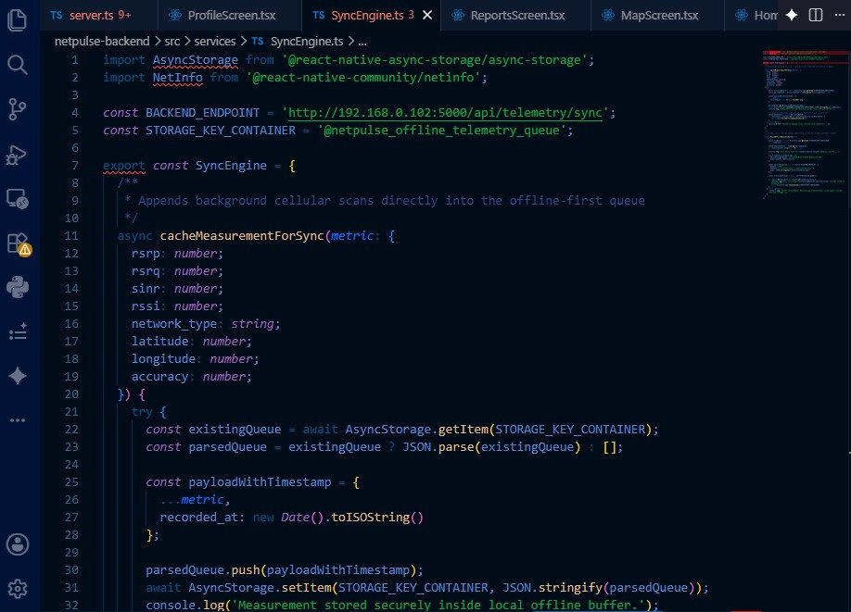
Figure 15: SyncEngine.ts implementation of the offline-first telemetry queue. cacheMeasurementForSync() reads the existing @netpulse_offline_telemetry_queue from AsyncStorage, appends the new metric with a recorded_at timestamp, and writes the updated queue back to local storage before it is later synchronised with the backend endpoint at /api/telemetry/sync.

2.6 Initial Backend System Implementation
The backend layer was introduced to provide communication between the mobile application and the database system. The backend was implemented using Node.js with Express.js. The responsibility of the backend is to:
- receive telemetry measurements from mobile devices;
- validate incoming data;
- process requests;
- store information inside PostgreSQL;
- retrieve stored measurements when required.
The backend follows a REST API architecture where the mobile application communicates with the server using HTTP requests. The backend separates application logic from database operations, making the system easier to maintain and extend. This early single-purpose telemetry service was later consolidated into the versioned /api/v1 REST API described in Section 7.

2.7 Initial REST API Design
The telemetry collection service exposes an endpoint responsible for receiving network measurements. The mobile application sends a JSON payload containing the collected cellular information; the backend receives this information, verifies the structure, and forwards it to the database layer. After successful storage, the server returns a confirmation response to the mobile application. In the deployed implementation this endpoint is exposed as:
POST /api/telemetry/sync
The server-side handler, reproduced below, destructures the device_fingerprint and validatedMeasurements array from the request body, returns early with a success response when there is nothing to persist, and otherwise opens a transaction and loops over each measurement, inserting it into the network_measurements table with a PostGIS geography point built from ST_SetSRID(ST_MakePoint(longitude, latitude), 4326).
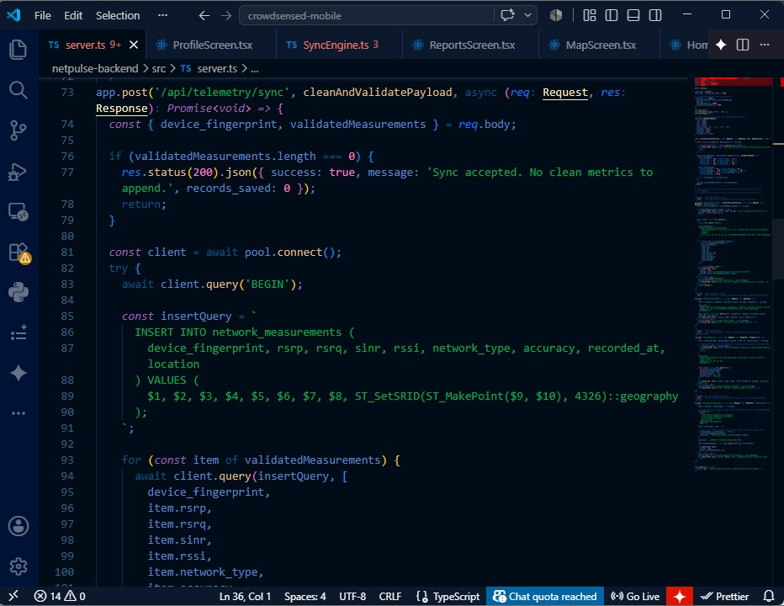
Figure 16: server.ts implementation of the POST /api/telemetry/sync endpoint, showing the parameterised insertQuery that writes device_fingerprint, rsrp, rsrq, sinr, rssi, network_type, accuracy and recorded_at alongside a PostGIS-encoded location column for each validated measurement.

2.8 Initial PostgreSQL Database Design
The database system was designed using PostgreSQL because the application requires reliable storage, structured querying, and future support for spatial network analysis. The main database entity is the telemetry measurement table. The table structure was designed to represent one network observation collected from one device at a specific time and location.
The primary key uniquely identifies every measurement record. The device_id field identifies the source device that generated the measurement. The timestamp field records when the measurement was collected. Signal-related fields store the cellular quality indicators obtained from TelephonyManager. The latitude and longitude fields allow future visualisation of coverage quality on a geographical map.
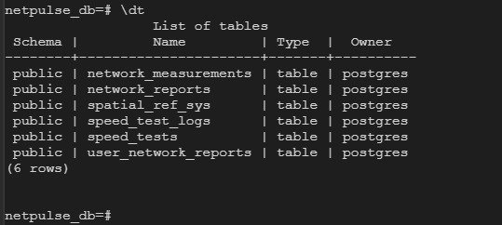

2.9 Initial Backend–Database Connection
The backend connects to PostgreSQL through a database connection layer. The connection configuration contains:
- database host;
- database port;
- database name;
- database username;
- database password.
The backend uses a PostgreSQL client library to create a reusable connection pool. The connection pool improves performance because multiple API requests can reuse existing database connections instead of creating a new connection every time. When the telemetry endpoint receives data, the backend executes an SQL insertion query that stores the measurement permanently. This early connection approach was later formalised into the environment-driven configuration and managed pool described in Section 7.2 and Section 7.3.

3. Data Elements
The CrowdSensed system manages six categories of data corresponding to the core functions of network measurement collection, user management, issue reporting, coverage analysis, synchronisation, and system administration.

3.1 User and Authentication Data
Each user account stores a UUID primary key, username, email address, hashed password, role (admin, operator, or user), an active status flag, and creation and modification timestamps. Authentication uses JSON Web Tokens: short-lived access tokens valid for 15 minutes, and refresh tokens stored in the database with an expiry date and revocation flag to support multi-device session management.

3.2 Device Data
Each registered mobile device stores a UUID primary key, a foreign key linking it to the owning user, a hardware device identifier, device model, operating system version, application version, and a last-active timestamp. This enables the system to track the source of every measurement and manage application version compatibility.

3.3 Network Measurement Data
Network measurements are the core dataset of the platform. Each record captures a single observation from one device at one location and time. The signal indicators stored are:
- Reference Signal Received Power (RSRP) in dBm — the primary indicator of coverage availability.
- Reference Signal Received Quality (RSRQ) in dB — signal quality relative to interference.
- Signal-to-Interference-plus-Noise Ratio (SINR) in dB — desired signal versus noise.
- Received Signal Strength Indicator (RSSI) in dBm — total received radio energy.
- Network type (e.g., LTE, 5G NR) — the active radio technology.
- Physical Cell Identifier (PCI) — identifies the serving base station.
- Geographic location stored as a PostGIS GEOGRAPHY point (WGS 84).
- Measurement accuracy in metres and a synchronisation status flag.

Speed test results are stored in a linked table: download throughput (Mbps), upload throughput (Mbps), and round-trip latency (ms), each tied to a parent measurement record.

3.4 Network Operator Data
A reference table stores the operator name, Mobile Country Code (MCC), Mobile Network Code (MNC), and country for each monitored operator. This table is joined to measurements and coverage cells to support per-operator analytics and comparison.

3.5 Issue Report Data
Issue reports are submitted by users to flag network problems. Each report links to the submitting user and optionally to a specific measurement as supporting evidence. Fields include issue type, free-text description, a PostGIS GEOGRAPHY location, processing status (pending, approved, rejected), and a confidence score computed from nearby measurements.

3.6 Coverage, Analytics, and Administrative Data
Coverage cells store pre-aggregated spatial data per operator: a PostGIS GEOGRAPHY polygon, average RSRP and SINR values, sample count, and coverage status. An analytics cache table stores JSONB summaries with time-to-live expiry to reduce repeated computation. A synchronisation queue manages offline-to-online data transfer from mobile devices. User settings, active sessions, and a system audit log complete the administrative data layer.

4. Conceptual Design
The conceptual design identifies the main entities in the CrowdSensed system and the high-level relationships between them. The diagram below shows these relationships independently of any database implementation detail.

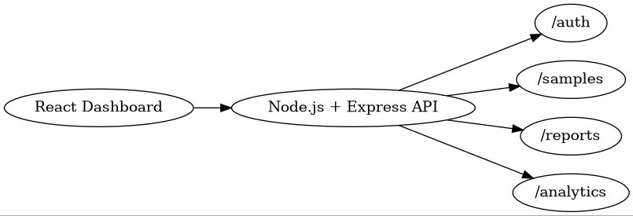
Figure 1: Conceptual Design Diagram — Entity relationships in the CrowdSensed system.

The Users entity is the central actor. Users collect Network Samples through the mobile application, which measures signal indicators and transmits them to the platform. Users also submit Issue Reports to flag observed network problems. Network Samples generate Coverage Zones through a spatial aggregation process that groups measurements by geographic cell and computes average signal values. Issue Reports may reference Network Samples as quantitative evidence, providing a confidence basis for administrators reviewing reports.

5. Entity-Relationship (ER) Diagram
The ER diagram extends the conceptual model with full attribute-level detail: primary keys, foreign keys, data types, and relationship labels for all eleven tables. The complete schema is described below.

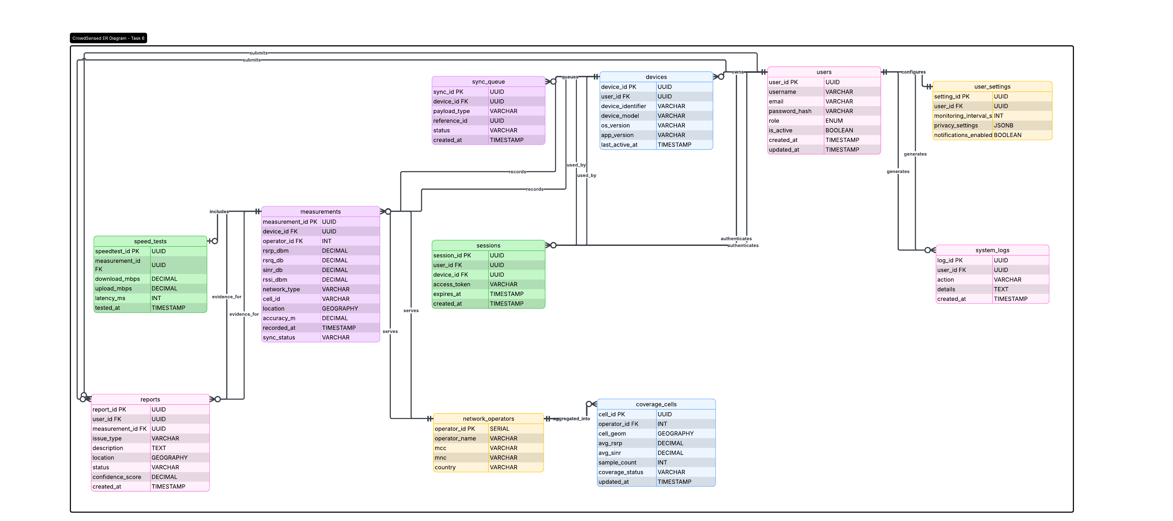
Figure 2: Entity-Relationship (ER) Diagram — Full schema for all eleven CrowdSensed tables with attributes, primary keys, foreign keys, and named relationships.

The named relationships and table schema are summarised below:

Table | Primary Key / Foreign Keys / Key Attributes
users | PK: user_id (UUID) | username, email, password_hash, role (ENUM), is_active, created_at, updated_at
devices | PK: device_id (UUID) | FK: user_id | device_identifier, device_model, os_version, app_version, last_active_at
measurements | PK: measurement_id (UUID) | FK: device_id, operator_id | rsrp_dbm, rsrq_db, sinr_db, rssi_dbm, network_type, cell_id, location (GEOGRAPHY), accuracy_m, recorded_at, sync_status
network_operators | PK: operator_id (SERIAL) | operator_name, mcc, mnc, country
speed_tests | PK: speedtest_id (UUID) | FK: measurement_id | download_mbps, upload_mbps, latency_ms, tested_at
reports | PK: report_id (UUID) | FK: user_id, measurement_id | issue_type, description, location (GEOGRAPHY), status, confidence_score, created_at
coverage_cells | PK: cell_id (UUID) | FK: operator_id | cell_geom (GEOGRAPHY), avg_rsrp, avg_sinr, sample_count, coverage_status, updated_at
sync_queue | PK: sync_id (UUID) | FK: device_id | payload_type, reference_id, status, created_at
user_settings | PK: setting_id (UUID) | FK: user_id | monitoring_interval_s, privacy_settings (JSONB), notifications_enabled
sessions | PK: session_id (UUID) | FK: user_id, device_id | access_token, expires_at, created_at
system_logs | PK: log_id (UUID) | FK: user_id | action, details, created_at

The named relationships are: users owns devices (one-to-many); devices records measurements (one-to-many); measurements serves a network_operator (many-to-one); measurements includes speed_tests (one-to-one); users submits reports (one-to-many); reports references a measurement as evidence_for (many-to-one); measurements are aggregated_into coverage_cells by operator; devices queue records through sync_queue; users configure user_settings; users authenticate via sessions; and user actions are recorded in system_logs.

6. Database Implementation
This section describes how the schema defined in Section 5 was implemented using PostgreSQL 15 with the PostGIS spatial extension.

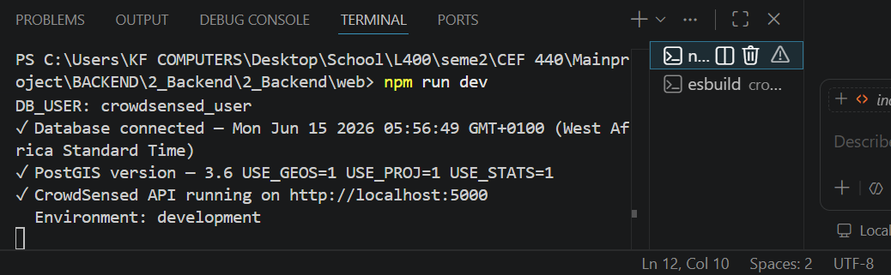
Figure 3: Database Implementation Architecture — PostgreSQL + PostGIS engine managing the core operational tables.

6.1 PostgreSQL and PostGIS Setup
PostgreSQL 15 was installed together with the PostGIS extension. PostGIS is required because the measurements table stores each sample's location as a PostGIS GEOGRAPHY column to support spatial queries such as the coverage heatmap. Installation on the development machine was performed with:
sudo apt update
sudo apt install postgresql-15 postgresql-15-postgis-3
sudo systemctl start postgresql

6.2 Database, Role and Extensions
A dedicated database role and database were created so that the application connects with its own credentials rather than the postgres superuser. The required extensions were then enabled inside the new database:
CREATE ROLE crowdsensed_user LOGIN PASSWORD 'crowdsensed_pass_2026';
CREATE DATABASE crowdsensed OWNER crowdsensed_user;
\c crowdsensed
CREATE EXTENSION IF NOT EXISTS postgis;
CREATE EXTENSION IF NOT EXISTS "uuid-ossp";
CREATE EXTENSION IF NOT EXISTS pgcrypto;

6.3 Running schema.sql
The schema script was executed to create all tables, indexes, views and triggers. The seven core tables created by schema.sql are summarised below.

Table | Purpose
users | Registered accounts with roles (admin, operator, user), hashed passwords, region and status.
refresh_tokens | JWT refresh tokens with expiry and revocation tracking.
network_samples | Signal measurements, including a PostGIS geography column for spatial queries.
issue_reports | User-submitted network problem reports with location, status and confidence score.
coverage_zones | Pre-aggregated coverage zone data cached from sample computations.
push_tokens | Firebase / FCM push notification tokens per device.
analytics_cache | JSONB cache of computed dashboard summary values with a TTL.

6.4 Indexes and Seeding
GIST indexes were created on all GEOGRAPHY columns for spatial query performance. B-tree indexes were added on foreign keys and the recorded_at timestamp column to accelerate analytics time-range queries. A seed script inserted 13 user accounts, reference records for MTN, Orange, and Camtel operators, 200 network measurements, and a set of issue reports at various processing statuses.

6.5 Live Verification of Deployed Schema
To confirm that the schema described in Section 6.3 was correctly created on the live database server, a psql session was opened directly against the deployed database and the \dt meta-command was used to list every relation actually present, independently of the schema.sql source file.
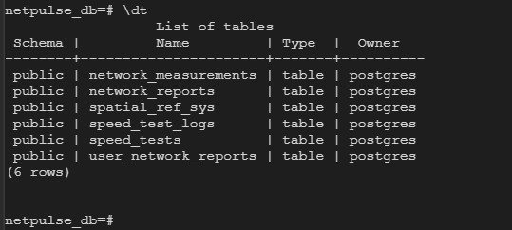
Figure 17: psql \dt output for the deployed netpulse_db database, listing network_measurements, network_reports, spatial_ref_sys (the PostGIS system table), speed_test_logs, speed_tests, and user_network_reports.
The listing confirms that the PostGIS extension is active, since spatial_ref_sys is present, and that the core measurement, reporting and speed-test tables were created successfully on the running server. This provides direct command-line evidence that complements the schema description and seeding results discussed earlier in this section.

7. Backend Implementation
Architecture.


The backend was implemented as a standalone Node.js project using the Express.js framework. It exposes a versioned REST API under /api/v1 and connects to PostgreSQL through a managed connection pool. The diagram below shows the backend routing architecture.

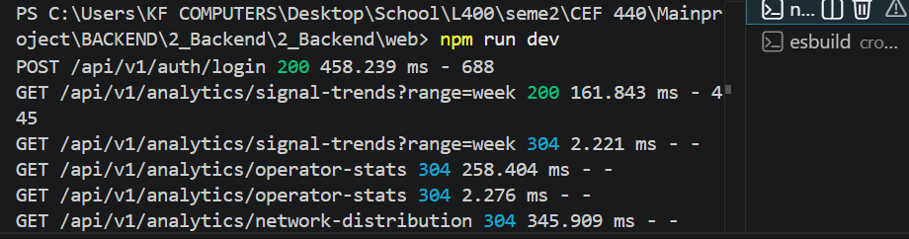
Figure 4: Backend Implementation Architecture — React Dashboard communicates with the Node.js + Express API, routing to /auth, /samples, /reports, and /analytics endpoint groups.

7.1 Setting Up the Node.js Project
The backend source is a standalone Node.js and Express project, kept outside the React project as a sibling folder so the two codebases remain independent:
crowdsensed/
crowdsensed-web/ <- React frontend
crowdsensed-backend/ <- Node.js backend
Dependencies were installed with:
cd crowdsensed-backend/
npm install

7.2 Environment Configuration
The .env.example template was copied to .env and populated with the database credentials, JWT secrets, and CORS origins. The values used were:

Variable | Value Used
DB_HOST / DB_PORT | localhost / 5432
DB_NAME | crowdsensed
DB_USER / DB_PASSWORD | crowdsensed_user / crowdsensed_pass_2026
JWT_SECRET / JWT_REFRESH_SECRET | Two distinct random 64+ character strings
JWT_EXPIRES_IN / JWT_REFRESH_EXPIRES_IN | 15m / 30d
CORS_ORIGINS | http://localhost:3000,http://localhost:5173
PORT / NODE_ENV | 5000 / development

7.3 Starting the API Server
Running npm run dev started the Express server in watch mode. The terminal output confirmed a successful PostgreSQL connection, the active PostGIS version, and the API listening on port 5000.

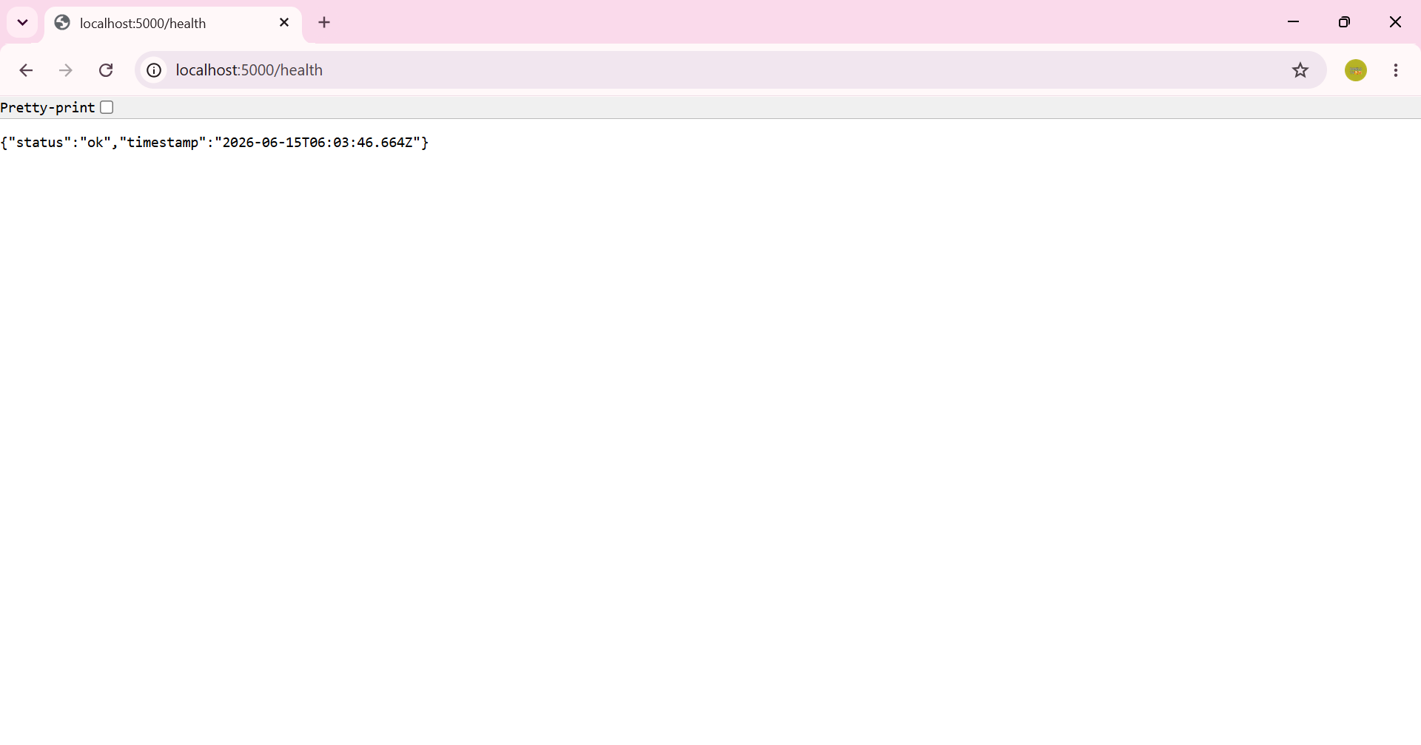
Figure 5: Backend startup log showing the database connected, PostGIS 3.6 detected, and the CrowdSensed API running on http://localhost:5000.
This confirms that the database connection settings configured in .env, and the PostGIS extension installed in Section 6.1, are correctly working together.

7.4 Health Check Endpoint
With the server running, the unauthenticated /health endpoint was requested directly in the browser to confirm the API was reachable on its own.

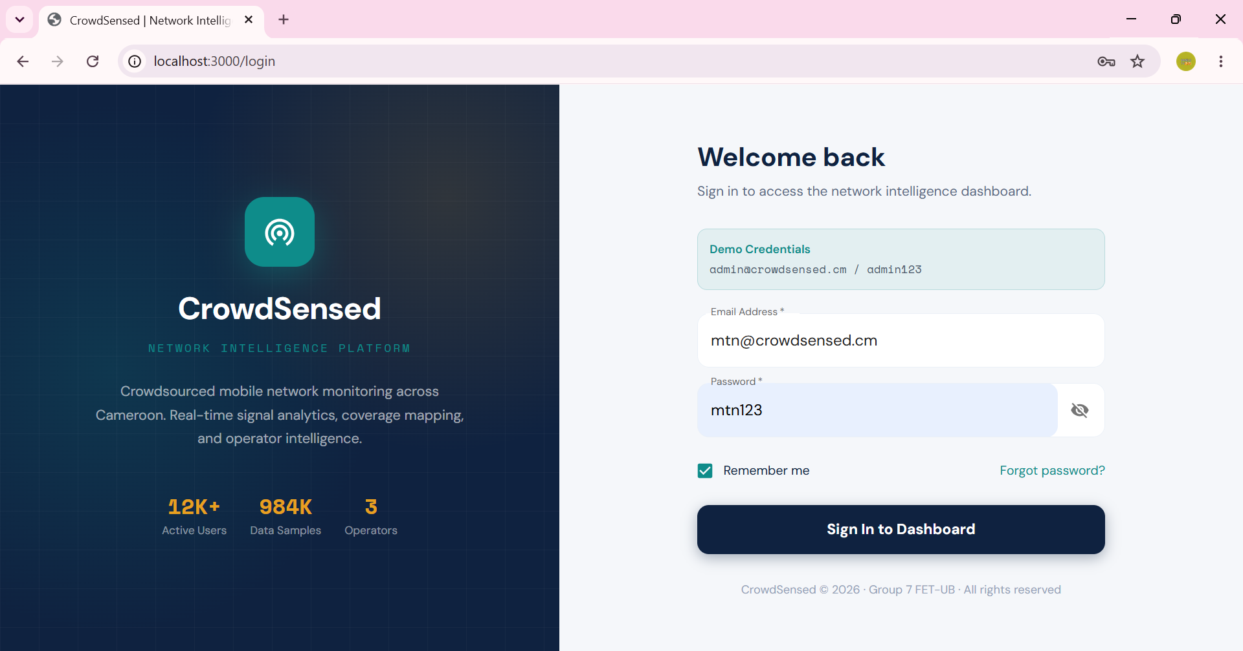
Figure 6: GET /health returning {"status":"ok"}, confirming the API is live on port 5000.

7.5 API Endpoints
The backend exposes a versioned REST API under /api/v1, covering authentication, sample data, issue reports, analytics and coverage data for the dashboard. The endpoints implemented and tested are listed below.

Area | Endpoints
Auth | POST /auth/register, POST /auth/login, POST /auth/refresh, POST /auth/logout
Samples | POST /samples/batch, GET /samples
Reports | POST /reports, GET /reports, PATCH /reports/:id
Analytics | GET /analytics/summary, /signal-trends, /operator-stats, /network-distribution, /hourly
Coverage | GET /coverage/heatmap, GET /coverage/zones
Users | GET /users, PATCH /users/:id/status, GET /users/me
System | GET /health (no authentication required)

8. Connecting the Database to the Backend
This section describes the full integration of all system components into a complete operational data pipeline. Both the mobile application and the web dashboard communicate with the Node.js backend via REST API, and the backend communicates with PostgreSQL/PostGIS via SQL queries.

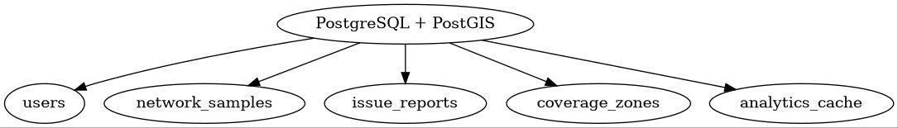
Figure 7: Database-to-Backend Connection Diagram — Mobile App and React Web Dashboard communicate with the Node.js Backend via REST API (Axios/JWT); the backend sends SQL Queries to PostgreSQL/PostGIS.

8.1 Wiring the Dashboard to the API
The connection files were copied into crowdsensed-web/. A new services/ folder was created to hold api.ts, an Axios client configured with request and response interceptors that automatically attach the JWT access token and refresh it when needed. The Redux slices for auth, dashboard, map, reports and users were updated to dispatch real requests against this client instead of returning static mock data, and vite.config.ts was updated with a development proxy.
With an empty VITE_API_URL in .env.local, every request from api.ts is relative (e.g., /api/v1/auth/login). Vite's development proxy forwards anything starting with /api to http://localhost:5000, avoiding cross-origin issues during development.

8.2 Verifying Live Login
The dashboard was started and opened at http://localhost:3000/login. Two accounts seeded by seed.sql were used to test both access levels: admin@crowdsensed.cm / admin123 for full admin access, and mtn@crowdsensed.cm / mtn123 for the restricted MTN operator role.

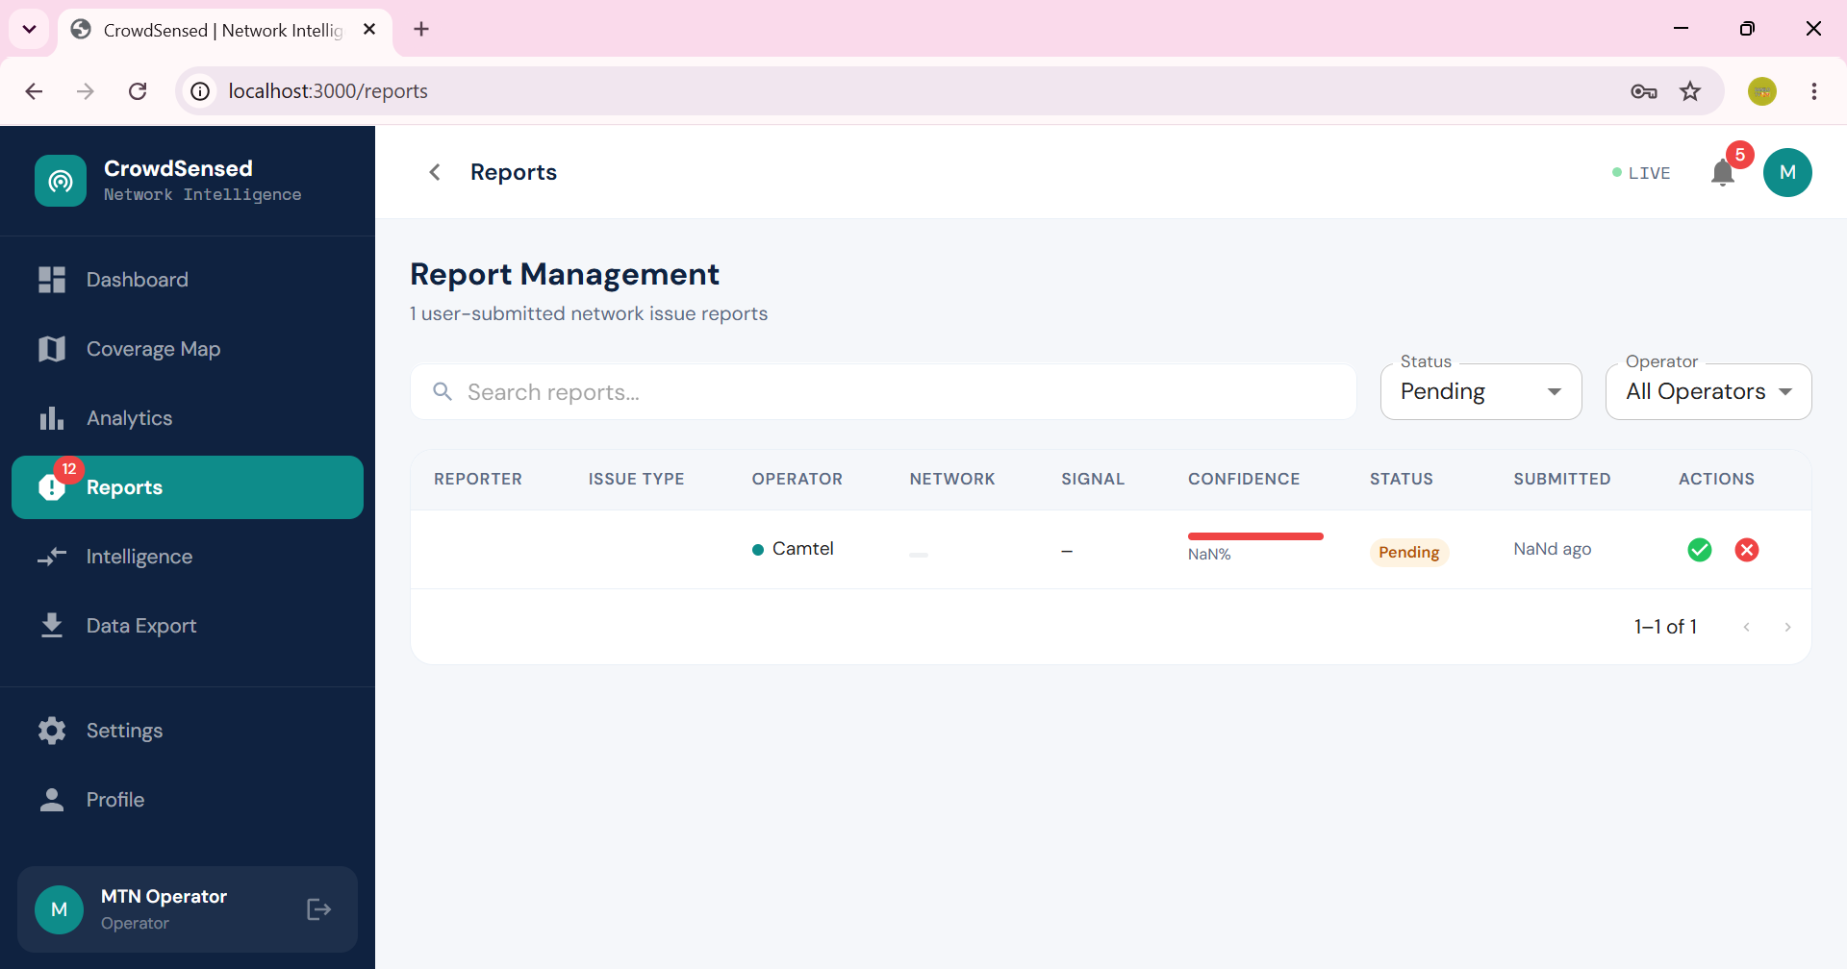
Figure 8: Live login screen at localhost:3000/login, with the MTN operator demo credentials entered, ready for POST /api/v1/auth/login.

8.3 Confirming Real API Traffic
To confirm the dashboard was no longer using mock data, the backend's request log was checked immediately after logging in and navigating the dashboard. The log shows a successful POST to /api/v1/auth/login returning HTTP 200, followed by GET requests to the analytics endpoints. Repeated requests correctly return 304 Not Modified, confirming caching headers are working.

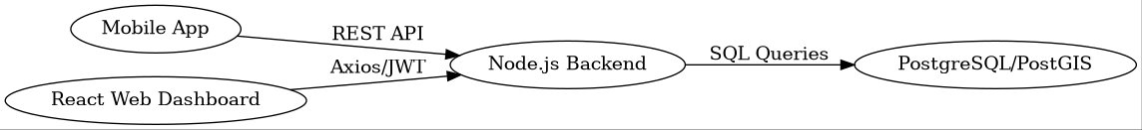
Figure 9: Backend access log showing a successful login (200) followed by live analytics queries from the dashboard (200 and 304 responses).


Figure 10: Backend request log confirming live API traffic from the web dashboard.

8.4 Reports Management Page
The Reports page queries GET /api/v1/reports?status=pending and renders each row from the issue_reports table. The screenshot below shows a pending report from a Camtel subscriber, with the Approve and Reject buttons wired to PATCH /api/v1/reports/:id.

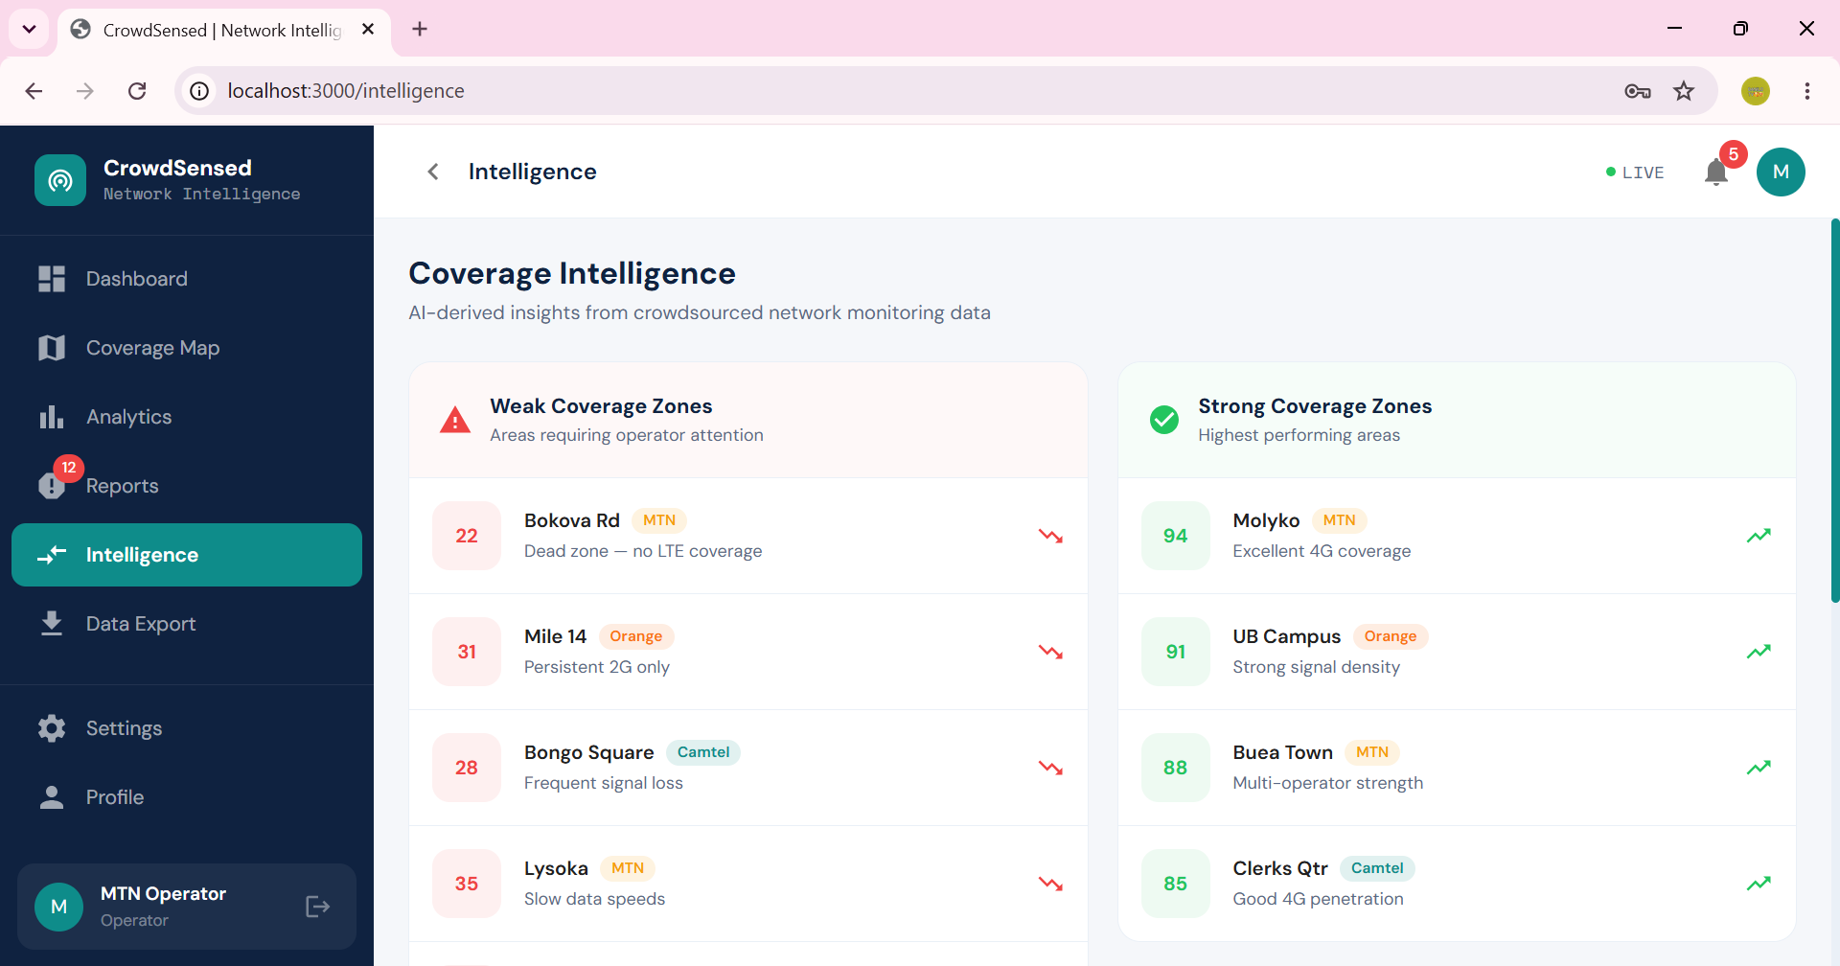
Figure 11: Report Management page listing a pending issue report retrieved live from the database.


Figure 12: Additional view of the Reports Management interface showing live data from PostgreSQL.

9. Coverage Intelligence Feature
In addition to the endpoints described above, the analytics layer includes a Coverage Intelligence page. Its purpose is to turn raw network_samples data into operator-facing insight, ranking zones by a computed coverage score and flagging which ones need attention.

9.1 Weak and Strong Zone Classification
The Intelligence page splits zones into two lists. Weak Coverage Zones score below a configurable threshold and are labelled with the likely cause derived from the dominant network type and signal strength for that zone — for example, "Persistent 2G only" or "Dead zone, no LTE coverage". Strong Coverage Zones are the highest-scoring areas, labelled with the property that drove the score up, such as consistent 4G coverage.


Figure 13: Coverage Intelligence page showing Weak Coverage Zones (e.g., Bokova Rd, score 22) and Strong Coverage Zones (e.g., Molyko, score 94, excellent 4G coverage), computed from the seeded data.


Figure 14: Additional Coverage Intelligence view showing ranked zone analysis and operator-facing recommendations.

9.2 Why This Matters for Operators
Because the score and labels are computed from live data rather than fixed values, the Intelligence page reflects new samples as they are added to the database. An operator such as MTN can use this page to prioritise maintenance: a zone repeatedly flagged as a dead zone is a stronger signal for dispatching a technician than a single complaint. This demonstrates how data stored in PostgreSQL is aggregated by the analytics routes and presented as an actionable recommendation on the web dashboard.

10. Verification Summary
Each part of the stack was verified individually before confirming the full pipeline worked together.

10.1 Database
- PostgreSQL service active and accepting connections.
- \dt inside the crowdsensed database lists all 7 expected tables.
- PostGIS_Version() returns 3.6, confirming spatial functions are available.
- 13 seeded users and 200 seeded network samples confirmed by row counts.

10.2 Backend
- npm run dev prints the database-connected, PostGIS-version and API-running confirmations (Figure 5).
- GET /health returns {"status":"ok"} (Figure 6).
- POST /api/v1/auth/login returns 200 with token and refreshToken fields (Figure 9).
- Analytics endpoints (signal-trends, operator-stats, network-distribution) return live data.

10.3 Web Dashboard
- npm run dev serves the dashboard at http://localhost:3000.
- Login succeeds for both the admin and MTN operator demo accounts (Figure 8).
- Reports Management lists seeded issue reports with working Approve and Reject controls (Figure 11).
- Coverage Intelligence page renders ranked weak and strong zones from real analytics data (Figure 13).

10.4 Outcome
The database is reachable and seeded correctly, the Node.js API starts cleanly and reports its own health, and the web dashboard authenticates against real accounts and renders live data from PostgreSQL. The Coverage Intelligence feature confirms that the analytics pipeline turns raw samples into operator-facing insight. All system architecture diagrams in Sections 4 through 8 document the design decisions behind this implementation. The web dashboard backend and database implementation is therefore considered complete and verified.

11. Conclusion
This report has documented the complete Task 6 deliverables for the CrowdSensed Mobile Network Monitoring System: the mobile application’s transition from a simulated prototype to real network telemetry collection, the data elements managed by the system, the conceptual design, the ER diagram, the database implementation, the backend implementation, and the database-to-backend connection.
The data model consists of eleven tables covering user accounts, devices, cellular signal measurements, network operators, speed tests, issue reports, coverage cells, synchronisation queues, user settings, sessions, and audit logs. PostgreSQL 15 with PostGIS provides reliable relational storage with native geographic data support. The Node.js and Express backend exposes a secure, versioned REST API that serves as the sole gateway between all client applications and the database. The web dashboard and mobile application both consume this API, the former displaying aggregated analytics and the latter submitting real measurements collected via the Android TelephonyManager framework.
The Crowdsensed Mobile Network Monitoring Application has therefore evolved from a static frontend demonstration into a complete mobile network measurement platform. The removal of simulated data, described in Section 2.1, ensures that all displayed and stored information originates from real device hardware rather than generated values. Integration with Android TelephonyManager, described in Section 2.2 and Section 2.3, enables direct access to cellular signal measurements, while the offline-first AsyncStorage queue described in Section 2.5 and shown in Figure 15 guarantees that collected data is not lost during temporary connectivity interruptions before it is synchronised with the Node.js backend and persisted in PostgreSQL.
All components were individually verified and confirmed operational as an integrated system, establishing a reliable foundation for future capabilities including machine-learning-based coverage prediction, real-time alert generation, large-scale crowdsensing analytics, and expanded operator comparison features.

